Shetland  Islands  Council  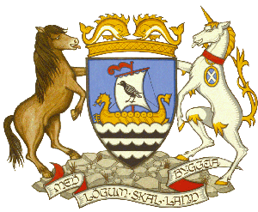  Children’s Services | School Improvement Framework  Policy  This policy replaces Shetland Islands Council’s Policy for Quality Assurance and Continuous Improvement (2012).  Children’s Service  June 2017

Contents

- Introduction 3
- Purpose and Aims 3
- Rationale 4
- Principles 8
- Core Elements 9

Appendices

- School Improvement Planning and Standards and Quality Reporting – Operational Guidance
- Visits to Schools – Operational Guidance

1. Introduction

Shetland Islands Council’s Children’s Services vision is: Outstanding Outcomes for All.

Within that, the aims of all school staff and central officers are:

- to provide a high quality of education that continuously raises attainment and achievement for all young people in Shetland;

- to ensure equity for all, with particular regard paid to those with disadvantages due to disability, learning difficulties, and socio-economic status, and to intervene as early as possible to secure this;

- to ensure that our young people succeed in moving to positive destinations on leaving school;

- to give young people a strong voice in decisions about their learning and about the running of their schools.

It is the responsibility of everyone to ensure that planned actions to secure improvement take place. In order to improve, we need to know how well we are doing already. This requires a culture of continuous self-evaluation for improvement in every school, and at every level in every school, to secure excellent learning and teaching in every classroom.

2. Purpose and Aims

The purpose of this policy is to provide a coherent framework to guide the work of everyone involved in improving quality in Shetland’s schools.

It sets out expectations and guidance to enable schools, the Schools and Quality Improvement Services, and partners to work together within a cycle of continuous improvement.

It aims to build the capacity of all pupils, staff, parents, carers and other partners to work together to undertake robust and accurate self-evaluation.

It encourages all to look inwards, outwards and forwards to help secure improvement.

It encourages collaboration between a wide range of partners to help secure improvement.

It emphasises the importance of evidence in planning for improved outcomes for children and young people.

It is designed to be flexible enough to meet the needs and context of individual schools.

Finally, it recognises that School Improvement cannot be separated from high-quality professional learning and Professional Review and Development for staff.
3. Rationale

Continuous improvement is a desirable goal in its own right. It is what learning and teaching are about, and it is what schools aspire to, both for their own sakes and in order to serve as a model for their pupils.

Shetland Islands Council’s approach to quality improvement takes full account of six national requirements and trends, which are described in the sections that follow.

- The Legislative Framework

- The National Improvement Framework (NIF)

- Intelligent Accountability

- Validated Self-evaluation

- Proportionate Support and Challenge for Schools

- Collaboration Between Partners

- The Legislative Framework

In Scotland, the statutory framework for quality improvement in schools and Education Authorities was established by the Standards in Scotland’s Schools Etc. Act 2000.

In summary, the Standards in Scotland’s Schools Etc. Act 2000 and subsequent acts of the Scottish Parliament require Education Authorities to:

- ensure that children’s education is directed to the development of their personality, talent and mental and physical abilities to their fullest potential;
- secure improvement in the schools for which they are responsible, with a view to reducing inequalities of outcome and achieving the priorities of the National Improvement Framework;
- produce annual plans and reports on their steps to reduce inequalities of outcome and on their steps towards achieving the priorities of the National Improvement Framework;
- ensure that schools publish annual Improvement Plans, including their strategy for parental involvement, in consultation with representatives of staff and parents, and after giving pupils and other interested parties the opportunity to make their views known;
- ensure that there is an annual report (usually called a Standards and Quality Report) on progress in implementing each school’s improvement plan, including their strategy for parental involvement;
- ensure that parents of pupils at the school have access to the improvement plan and the progress report, and receive summaries of both documents, without having to pay.
- The National Improvement Framework (NIF)

The Education (Scotland) Act 2016 links quality improvement to a new National Improvement Framework for Scottish Education. Its priorities, which may be altered by the Government in annual reviews, must by law be pursued by every education authority.

- Review of Standards in Scotland’s Schools etc. Act 2000

In line with the 2016 Education Act and statutory requirements to reduce inequalities of outcome for pupils experiencing them as a result of socio-economic disadvantage and the planning and reporting duties at school and education authority levels in respect of the National Improvement Framework, statutory guidance has been issued amending the Standards in Scotland’s Schools etc. Act 2000.

The link to the revised guidance is below:

http://www.gov.scot/Publications/2017/03/4559

The guidance is split into three parts, focusing on the following main issues:

- Pupils experiencing inequalities of outcome;
- National Improvement Framework and;
- Planning and reporting

There is further information about the National Improvement Framework in Appendix 1: School Improvement Planning and Standards and Quality Reporting.

- Intelligent accountability

An important principle of the 2000 Act is that schools and authorities are accountable for the quality of education children and young people receive. Shetland Islands Council considers itself, all its schools, and all its members of staff to be accountable to the whole community, and especially to parents and pupils, for the service they provide.

Being accountable requires robust monitoring and improvement activity which is aligned across schools and the education service. An essential part of that is the gathering and appropriate use of quantitative data, including data on pupils’ attainment. The analysis of data on national tests and qualification results includes use of tools such as Insight (the Government’s benchmarking tool for the Senior Phase). That in turn requires training for practitioners in how to interpret and use data to plan for improvement.

A wide range of evidence about many aspects of schools’ and pupils’ progress needs to be gathered, including evidence relating to all the drivers for improvement in the National Improvement Framework. The Scottish Government has stated that it and stakeholders ‘are considering how to gather further evidence on these aspects in future years’ (National Improvement Framework for Scottish Education: 2015 Interim Framework Report). This will include quantitative data wherever possible. But not all evidence is quantifiable. In the formal process of auditing evidence, the Quality Improvement Service and schools will guard against the danger of focussing only on easily measurable outcomes: this can distort the actions of schools and place an inappropriate emphasis on performance management, which is not in itself conducive to improving outcomes for pupils.

‘Intelligent accountability’ makes use of a wide range of data, both quantitative and qualitative, to give a balanced analysis of how a school is performing and what its priorities for improvement should be. It requires understanding of the reliability and relative importance of each type of data, and knowledge of the context within which the data was produced.

The core principles in Scottish educational policy are compatible with the concept of intelligent accountability, notably Curriculum for Excellence itself, which

- aims are to develop in all young people the four capacities: successful learners, confident individuals, responsible citizens, and effective contributors;

- identifies literacy, numeracy, and health and wellbeing as a crucial responsibility for all school staff;

- promotes personalised learning and choice;

- places trust in teachers’ professional judgement and creativity;

- recognises four different contexts for learning – curriculum areas and subjects, interdisciplinary learning, ethos and life of the school, and opportunities for personal achievement.

Only a few of the priorities in Curriculum for Excellence and the National Improvement Framework are numerically measurable, but all of them are important, and Quality Improvement is expected in all of them.

- Validated self-evaluation

Self-evaluation is the key to improvement. It is at the heart of ‘How good is our school?’ (4th Edition) (2015). ‘How good is our school?’ (4th Edition) is presented as a toolkit to underpin self-evaluation rather than a set of prescribed standards. It contains fifteen Quality Indicators, each of which is accompanied by features of highly effective practice and challenge questions. Practitioners and leaders should select the Quality Indicators or clusters of Quality Indicators that are appropriate to their needs and select or adapt the challenge questions that they use for self-evaluation. The challenge questions and features of highly effective practice as published are also to be revised periodically by Education Scotland, to reflect developing priorities and good practice observed in inspections.

‘Validated self-evaluation’ is the process by which the Quality Improvement Service either agrees or does not agree the school’s procedures for self-evaluation and the results of the school’s self-evaluation. The focus on self-evaluation validated by external authority reflects the practice of Education Scotland inspectors. However, validated self-evaluation is not the same as inspection: it is a partnership in which the Quality Improvement Service seeks to support and challenge schools’ own self-evaluation, and so strengthens outcomes for learners.

In Shetland, School Improvement Visits and Team Improvement Visits contribute significantly to validated self-evaluation. They are intended to help build the capacity of schools to evaluate their own performance and improve outcomes for pupils.

- Proportionate Support and Challenge for Schools

In seeking to support and challenge schools’ own self-evaluation, the Quality Improvement Service will use the same kind of challenge questions as are recommended for self-evaluation in ‘How good is our school?’ (4th Edition).

Taking a ‘proportionate’ approach means that the Quality Improvement Service will organise its support partly according to the evidence already available to it and partly according to requests from schools themselves.

It also means that the processes of gathering, processing and recording data at all levels will not be unduly onerous. Bureaucracy will be manageable and will relate closely to improving outcomes for learners.

A similar approach will be taken by Head Teachers and other managers within schools, to support the fullest development of every pupil.

- Collaboration between Partners

Curriculum for Excellence requires strong, effective partnerships as an essential part of improvement in Scottish education.

The fundamental collaboration in education is that between pupils, school staff (both teachers and others), and parents and carers.

‘How good is our school?’ (4th Edition) reinforces this and goes beyond it. It lists further partners in education: the third sector, youth workers, community learning and development staff, colleges, universities, employers who work with schools to deliver learning pathways to meet the needs of all young people, and other professionals with specialist expertise in additional support needs who will help remove barriers to learning and ensure all young people experience success in school and beyond school.

Self-evaluation is deepened by inviting partners to join the evaluation in a non-inspectoral capacity. ‘How good is our school?’ (4th Edition) encourages schools to use the Quality Indicators in collaboration with their peers and with a range of partners:

The framework emphasises and supports collaborative self-evaluation within school, between schools and with the wider range of stakeholders who contribute to children and young people’s learning and development. Children and young people’s active participation in self-evaluation is an important factor.

(‘How good is our school?’ (4th Edition), p. 11)
The National Improvement Framework agrees with this:

“Evaluating school improvement and work with partners will help us to focus on early and sustained intervention and support for children and their families. School inspection, school self-evaluation and local authority reporting on attainment and achievement will tell us how well schools are achieving equity for all children. We expect that this evaluation will be carried out increasingly with partners and other services.”

(National Improvement Framework for Scottish Education (2016), p. 18)

Collaborative self-evaluation within local partnerships is powerful in bringing about improvement in outcomes for children and young people. Such partnerships may sometimes be regulated through formal agreements. They depend on high levels of mutual trust and respect, and they create mutual accountability.

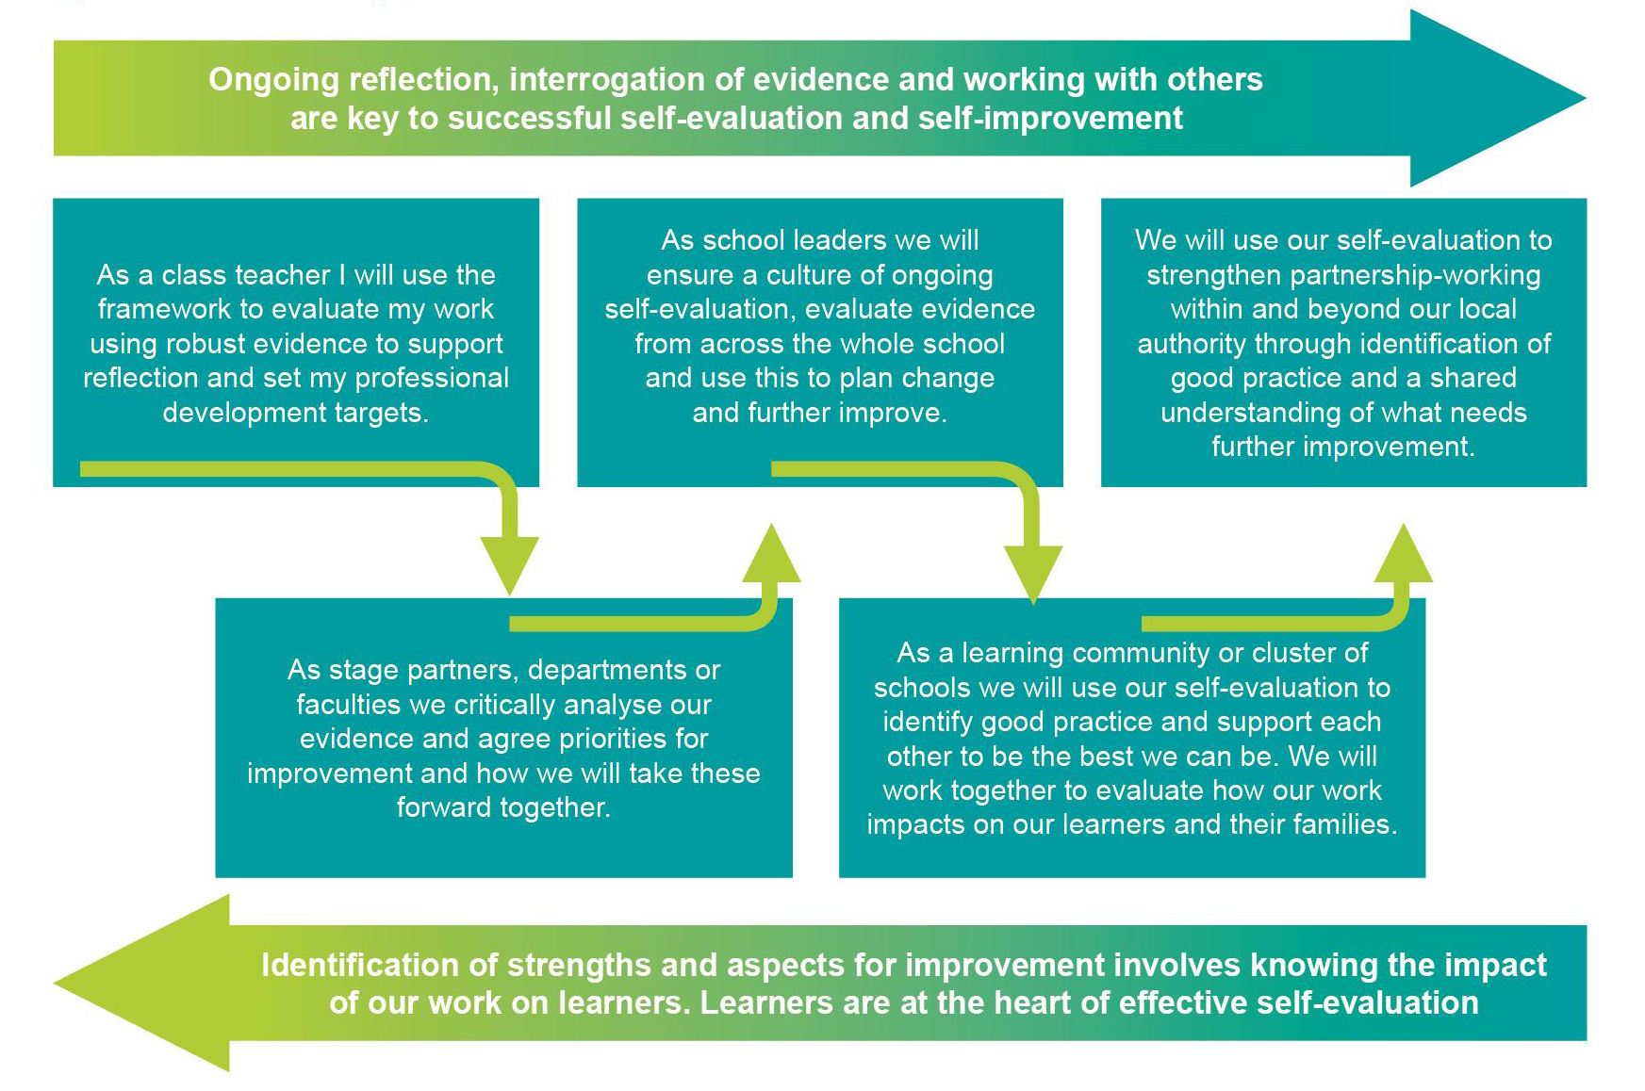

(Source: ‘How good is our school?’ (4th Edition), p. 10)

4. Principles

Shetland’s school improvement practices:

- avoid bureaucracy that is unmanageable and that does not improve outcomes for learners;
- place individual learners at the centre of the process and give them a voice in decisions about improving their schools;
- use a wide range of evidence to inform self-evaluation and improve outcomes for learners;
- are the responsibility of all, and promote partnerships and shared accountability;
- support and challenge learners, schools, and their partners, within an ethos of high aspiration;
- require and promote effective leadership at all levels;
- help practitioners to recognise, disseminate, and learn from effective practice;
- support professional learning for staff that leads to improved practice and improved outcomes for learners;
- are flexible and proportionate to the needs of individual schools.

5. Core elements

This School Improvement Framework comprises four elements. Every action within these elements must result in improved outcomes for children and young people.

- Self-evaluation for self-improvement

Refer to Appendix 1, ‘School Improvement Planning and Standards and Quality Reporting – Operational Guidance’.

- School Improvement Plans and Standards and Quality Reports

Refer to Appendix 1, ‘School Improvement Planning and Standards and Quality Reporting – Operational Guidance’.

- Support from central officers, including visits to schools

There are three main types of school visit (for details, refer to Appendix 2, ‘Visits to Schools – Operational Guidance’).

- School Support Visits

These can take place at any time, and for a variety of reasons, at the request of the Head Teacher or of the Quality Improvement Officer linked to the school.

- School Improvement Visits

These are carried out by the Quality Improvement Officer linked to the school, according to an agreed programme of at least two visits a session. Each visit will have a specific focus, as follows:

- Visit 1 (Terms 1 or 2): Attainment and achievement in the Broad General Education and Senior Phase
- Visit 2 (Terms 3 or 4): Self-evaluation and school improvement planning
- Visit 3 (optional): If a third visit takes place, its focus will be determined by national or local priorities at the time and agreed with Head Teachers.

- Team Improvement Visits

The purpose of a Team Improvement Visit is to validate and scrutinise the school’s own self-evaluation by gathering and analysing a wide range of evidence. An annual programme of Team Improvement Visits is drawn up by the Quality Improvement Officers.

- Professional Learning and Professional Review and Development

Refer to Shetland Islands Council’s separate (2016) Professional Learning Strategy for Teachers.

These four elements support a cycle of improvement.

Evidence is gathered in everyday work and at specific times in the school session. The evidence gathered is used to inform self-evaluation and identify targets for improvement. The targets and strategies for improvement are described in the School Improvement Plan, then reported on and evaluated in the school’s Standards and Quality Report. These are shared with the school’s Quality Improvement Officer.

Finally, high-quality professional learning opportunities are provided in accordance with the needs of the Service Plan, the School Improvement Plan, and individuals’ Professional Review and Development: highly trained professional staff are essential to sustaining a cycle of improvement.

Schools choose the improvement methods that will best meet their needs. The following cycle can be used to turn ideas into action and connect action to learning.

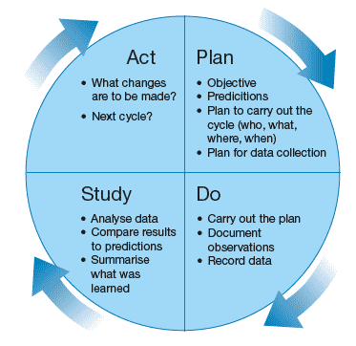

It may be appropriate for departments within secondary schools to follow a similar cycle, including their own improvement plans and standards and quality reports.

